Sandia Heights Homeowners Association (SHHA) Annual Meeting
Saturday, February 24, 2024
Church of the Good Shepherd, 7834 Tennyson Street NE
9:00 AM – 12:00 Noon
Minutes and attachments for 2024 Annual Meeting

Business Meeting
- Call to order and establishment of a quorum
Roger called to order, a quorum was established. Introduction of Jim Stewart, Eric Faulring, Heidi Komkov, Claudia Mitchell.
- Approval of the Agenda-Approved
- Approval of the Minutes of the 2023 Annual Meeting-Approved
- Introduction of the 2024 Board of Directors and SHHA Standing Committee Chairs – Introduced 2024 BOD per slide presentation, see Appendix A, pages 7 & 8 ; Introduction of office staff, Trish, Holly, Diane
- Election by membership of the 2024 Board of Directors – There was no election of the new Directors.
- Announcement of 2024 Officers and Board of Directors – Slide presentation, Appendix A, pages 7 & 8 show the list of new BOD
- Reports for 2023 to the membership by the Officers and Standing Committee Chairpersons' -- written reports are in the packet. – Handout Packet is attached in Appendix B.

- Presidents Report – Roger gave an overview on following the covenants and how that is important for SHHA.
- VP Report-Hugh has been homeowner since 1993, thank you for the opportunity to serve
- Secretary Report-Martin gave a brief overview, happy to serve
- Treasurer Report-Randy every 2 weeks into the office, recent changes on payroll
- ACC Chair-Phil overview/highlights to come
- C&P Chair-Susan will be handing it over to Claudia, new website, new directory
- CSC Chair-Art 20 year resident
- C&P Incoming Chair-Claudia submit new articles for GRIT
- CS&M Chair-Elizabeth Welcome to the community
- E&S Chair-Kathleen educate on safety, fire protection every 2 years

- Business meeting adjourns – Adjourned for a 20 minute break

Break - Enjoy Refreshments provided by SHHA Neighbor O’Bean’s

Question and Answer Session for Questions Submitted in Advance

The questions received by the SHHA Office one week in advance (February 17, 2024) will be responded to in the order received. The author of the question may request clarification as time permits. Questions submitted by members in writing today at the 2024 Annual Meeting will be responded to in writing directly to the member who asked the question within 30 days following the Annual Meeting. Please adhere to the Annual Meeting Procedures of Conduct (p. 3) ---- List of Questions to be answered are attached in Appendix C

Break - Enjoy Refreshments provided by SHHA Neighbor O’Bean’s

Community Forum on Universal Membership and Damages Assessment Policy

Members are invited to ask questions and share opinions regarding the topics of Universal Membership and the Damages Assessment Policy under consideration by the Board of Directors. Speakers will be limited to three minutes per recognition by the President.

Adjournment – Time: 12:02PM

Attachments:

Appendix A - 2024 slide presentation attached
Appendix B – Handout -Packet
Questions and Answers from the Annual meeting will be archived and sent in a different document.

Submitted Question / Answer Session: 24 submitted forms
- Martin read question from Franklin Schilling on dog barking

Art-SHHA cannot do anything about barking dogs, contact Bernalillo county
- Martin read question from Thomas Wagner on motorcycles on Tramway.

Kathleen – call BCSO, they do not get many calls and basically say they do not have the manpower to cover that.
- Martin read question from Deborah Griswold on Primrose Point and grass/water issue.

Kathleen - will take it as an assignment
- Martin read question from Kevin Lloyd on CSC reports and 31 complaints last year, 62 this year. How many were filed by CSC or Board members? Is this a trend to “policing the neighborhood”.

Art answered – we do not police the neighborhood. I don’t know how many complaints are filed by Board members, we can find this. My guess only a few.

Kathleen also answered by saying that she is also a member of the community. All residents can submit a violation. Only reported violations are investigated.
- Martin read question from Laurence Linford on how the community used to get benefits from the SHHA like pool, easter egg hunts, etc. What do you plan to do with the extra income from Universal membership? Will any of these activities be brought back?

Elizabeth - The pool was not run by SHHA and the land is Reservation owned. Easter Egg Hunt-those people retired, other activities do require volunteers, Tram tickets-we buy from the tram, Free concerts-can look into it for future. The community can step up and volunteer for concerts, egg hunts, etc.

Roger chimed in - Large reserve-by law we have to have a reserve to run the office.
- Martin read question from Woody Farber on answering questions and responses being sent to all members.

Reponses – we can’t put them on the website, this would make them public for the public to see.

Susan – we can send email as we do the for the GRIT but we may not have everyone’s email.
- How much of the member fees goes to the community? And how much goes to attorney fees?
- Hugh-Statute covers all HOAs in NM, this has passed by the Board and will be in effect in 2025.

Phil-Every HOA in NM is covered by the HOA Act

No other questions from the 24 submitted were addressed at the meeting.

FORUM on Damage Assessment and Universal Membership

Dave Crossley led the discussion on background information. Highlights included, currently the committees work the complaints/violations and our option are to go to the violator with a handful of daisies (ask) or go with a canon (lawsuit). Fines will only occur after asking and lawsuit does not work. We will not be looking for violations.

Made a comment that if people don’t like living here and buying into the covenants, they can go buy in the South Valley.

Art’s part of the discussion -CSC needs a more cost effective way to handle non compliance.

Phil-the intent is not to fine you, it is to get damages for your failure to comply. If you do not violate the covenants, then it does not apply to you. This motion has not been adopted by the board at this time but it did go to a vote.

QUESTIONS FROM FLOOR
- Lady asked about having a Clotheslines – Roger replied that ok if the location is hidden, maybe the collapsible type. Comment was made about the Utility companies not cleaning up after themselves anything SHHA can do?
- Resident asked: Been a resident for a long time, big change with the universal membership and why is it not being discussed. Universal membership-would like to see the opinion of Scott Turner on universal membership, vote should be required. She and others in the room are part Hispanics and was deeply offended, upset about the South Valley comment. Roger replied with the promise the Board will get the written opinion from Scott Turner and make it available.
- Lady in green sweater - Lien aspect, opposed to it. Felt it would be misused, and lead to much abuse.
- Nancy asked: Are these damages going to be retroactive? NO was the reply.
- Black sweater gentleman (Morales) -grateful for the opportunity to speak. He was the lawsuit that won and got to keep his shed. He spoke of the inconsistencies and inequitable methods used by the ACC on approval and disapproval of the application. Against the motions because they can’t and won’t be administered equitably.
- Brian Winter-potential for abuse, how will it get leveraged fairly?
- Black sweater, female (Judy): Didn’t get letter in mail. She heard 4 days ago of these proposals. Asking that notices are sent to those affected. Written request by law. Does not believe she was given notice. Asked why it took the Board 11 years to act on the interpretation of the HOA law?
- Marlene Flor-1987 built house, new neighbor in 2020-2021 built a shed, native vegetation was removed, view was blocked. The ACC approved these. Attorney was contacted to get documentation, she won suit against the board to just get the documentation. She believes her property declined in value by $20,000 property valued. Approval of the proposal, encourage the proposal.
- Marsha Thole-in favor of getting everyone in compliance with a more proactive approach, not aggressive damages. Why do we not see the applications that are not approved in the GRIT? This would give the neighborhood a sense of understanding and be transparent. ATF applications should be in the GRIT. Doubt that a realtor would take on a property that had many violations.
- Blue shirt man – there needs to be an intermediate step between asking nicely and then damages. There are other ways.
- Resident commented and asked: Appreciate the volunteers, glad that we are a non- profit, what sort of appeals process is there? The Board’s implementing the damages and they are the same Board that would hear an appeal. Would like another avenue instead of the damage assessments. It is too harsh.
- Lady red sweater-understands that this should happen in certain situations. The idea has merit but does not like the fact that the Board approved it alone, would like more community involvement.
- Charles, 6 years member commented: The motion lacks due process. This will turn into a “cash cow” for the Board and will promote the enforcement of vindictiveness. It’s a large step to go from “pain in the butt resident” to “financial gain and power”. He’s not a fan of the damages, liens, but how about an appeal board?
- Lady in gray sweater, Thank you for what you do as a Board. Huge problem about it being beneficial to the community. Does not agree with the proposal.
- Ron Vigil-been on boards and ACC since 1977, appreciate the need for enforcement for the 5% or so bad actors. Looked thru the proposal. Independent appeals process is needed to enforce bad actors, but not the money into the Association.
- Will-10 year resident, a lot of the core questions are around TRUST. Realistically, how do we know we can trust you. How quickly and often will you violate this trust? There seems to be an inability to talk to our members. This is too ripe for abuse. How about an Independent 3rd party?
- Kevin Lloyd commented that SHHA is set to join the annoying HOAs which are overreaching and have shown to devalue properties in America. It was voted on in Dec and failed by 6-7 vote. To the audience, without direct action from the community, the Board will pass this. This shows how they have lost sight of serving you. Often mentioned by the Board, that SHHA has over 2000 violation, why doesn’t the CSC have 2000 complaints? Pause.. Because nobody cares about them filing a complaint. Put a financial motivation behind these motions, this will created neighbor after neighbor. I’m working together with a group of volunteers to organize against this and for the Board to be transparent. Please join me.
- Tito Busani – Prior President of Board – The motions go to TRUST. The Board needs to disclose and needs transparency; our community needs to work together. President needs to create this TRUST. When the President & Board does not invite community involvement they become a dictator, not a democracy. There needs to be the option to choose, not to mandate the Board policy.
- If non-paid members cannot sit on Board – how are they represented?

- Lady in pink sweater-100% agree with universal membership, and with the damages assessment but why do we not have a community vote?

- Claudia P-15 year resident, figure out a good way to implement it, agrees with parts of it.

- Rob-nonmember-Covenants in S1 roofs are white, white houses in the neighborhood, into a lynching process. Have a big violation next door to me. This board has become pathetic.

Per Roger – sign up Members to be on Appeal committee or shown interests:

Jim Sorenson – 1544 Eagle Ridge Rd – 631.796.5204 – jms98@caa.columbia.edu

Diane Barney – 973 Antelope Rd – dianebarney@gmail.com

Tito Busani –505.550.8408 - busanit@unm.edu

Vivian George – maybe have hardship of meeting, lives out of area several months of the year. picaflordragon@gmail.com

APPENDIX A:

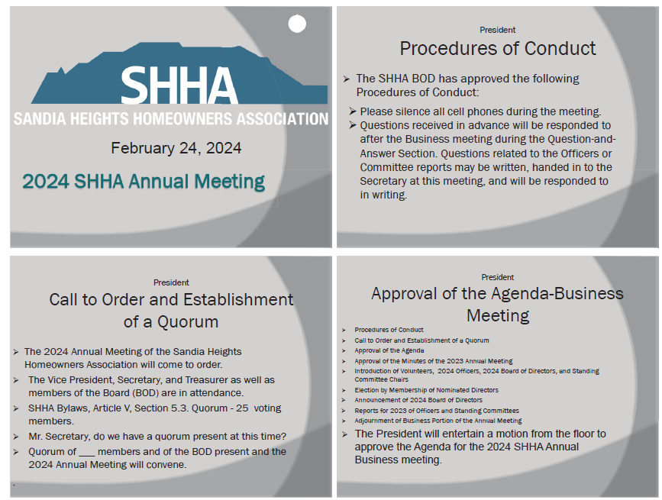

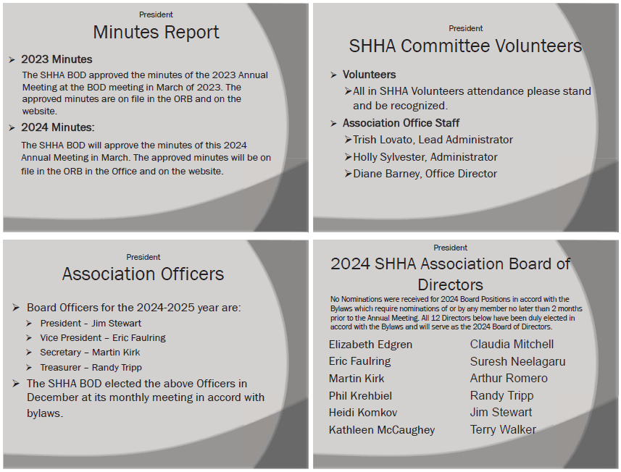

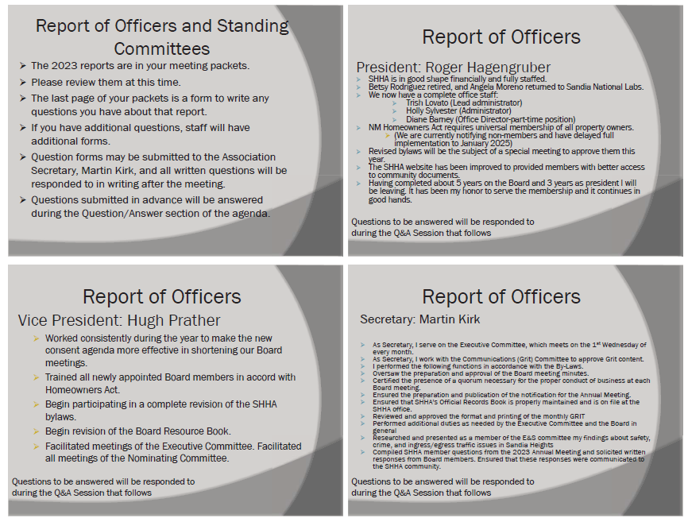

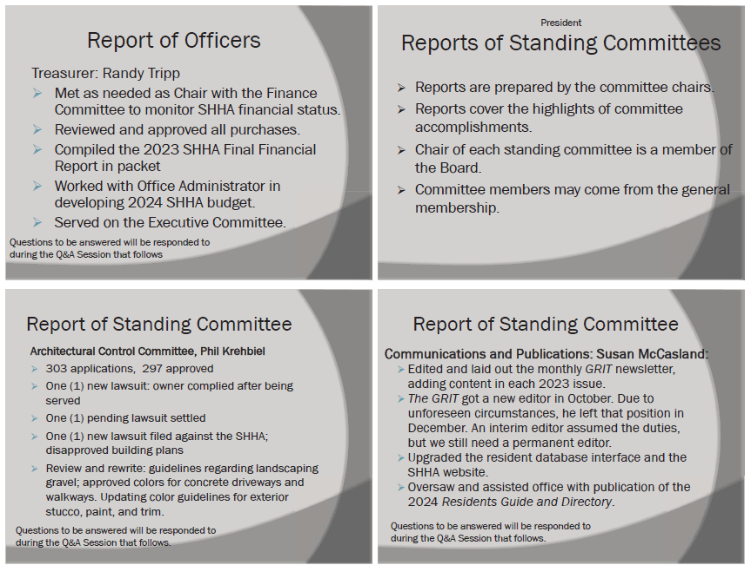

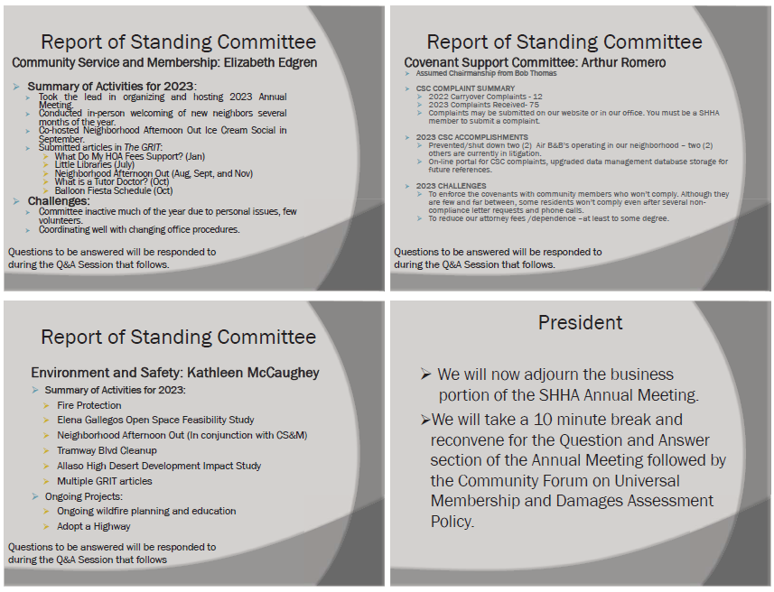

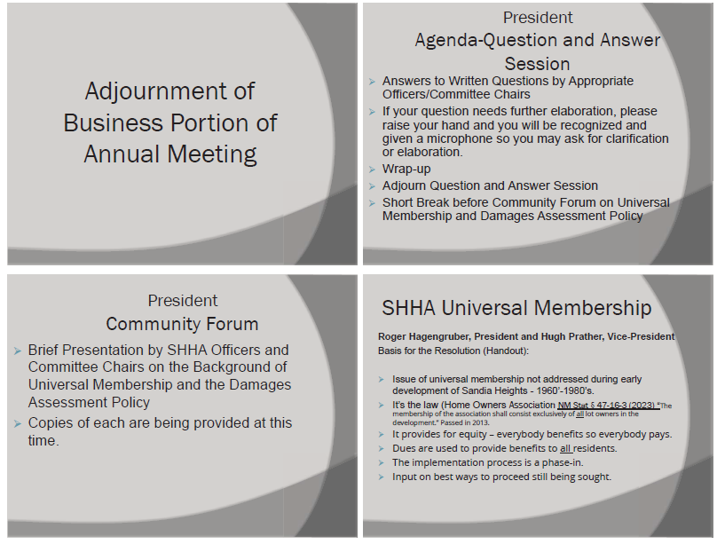

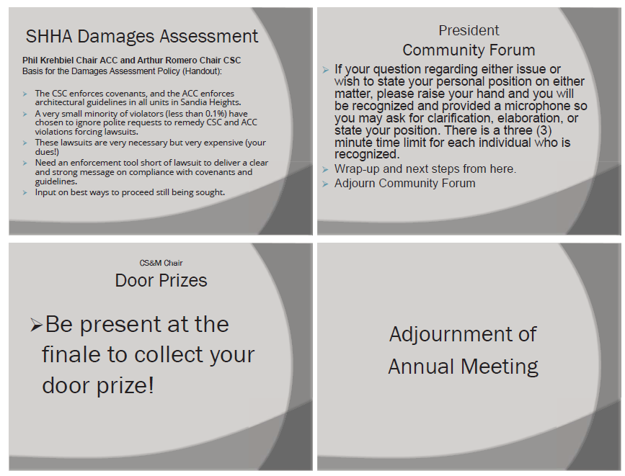

APPENDIX B – Handout – Packet for the Annual Meeeting

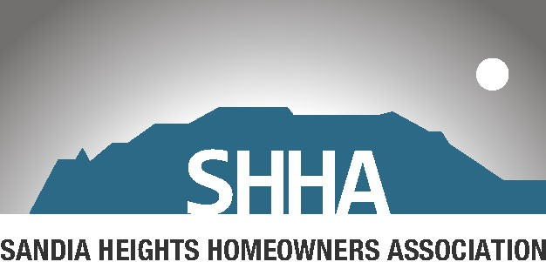

Annual Meeting
February 24, 2024

Church of the Good Shepherd
7834 Tennyson Street NE
Saturday, February 24, 2024
9:00 AM – 12:00 Noon

Agenda for 2024 Annual Meeting

Business Meeting
- Call to order and establishment of a quorum
- Approval of the Agenda
- Approval of the Minutes of the 2023 Annual Meeting
- Introduction of the 2023 Board of Directors and SHHA Standing Committee Chairs
- Election by membership of the 2024 Nominated Board of Directors
- Announcement of 2024 Officers and Board of Directors
- Reports for 2023 to the membership by the Officers and Standing Committee Chairpersons' -- written reports are in the packet.
- Business meeting adjourns

Break -Enjoy Refreshments provided by SHHA Neighbor O’Bean’s

Question and Answer Session for Questions Submitted in Advance

The questions received by the SHHA Office one week in advance (February 17, 2024) will be responded to in the order received. The author of the question may request clarification as time permits.

Questions submitted by members in writing today at the 2024 Annual Meeting will be responded to in writing directly to the member who asked the question within 30 days following the Annual Meeting. Please adhere to the Annual Meeting Procedures of Conduct (p. 3)

Break - Enjoy Refreshments provided by SHHA Neighbor O’Bean’s

Community Forum on Universal Membership and Damages Assessment Policy

Members are invited to ask questions and share opinions regarding the topics of Universal Membership and the Damages Assessment Policy under consideration by the Board of Directors. Speakers will be limited to three minutes per recognition by the President.

Adjournment

2024 SHHA Annual Meeting Procedures of Conduct

- Please silence all cell phones during meeting.

- Please enjoy your interactions with your friends and neighbors.

- Your questions which have been submitted in advance will be responded to in the order in which they were received.

- After the response to your question, the author of the question may have the floor for clarification of the response or the question.

- Questions which are written at the meeting will be handed in to the Secretary, for response within the 2024 Q&A guidelines in the Agenda.

- Before speaking, a member must be recognized by the President; please present yourself at a microphone to be recognized and state your name.

- Speakers will be limited to three minutes.

2024 Annual Meeting Reports of Officers

President: Roger Hagengruber

I was elected president of the Sandia Heights Homeowners Association at the December 9, 2020, Board meeting and took office after the 2021 Annual Meeting. The Board asked me to continue to serve as President for an additional year and I agreed. That year is coming to an end, and I will be leaving the presidency. It has been an honor to serve as President for 3 years and to participate on the Board and a committee for nearly 5 years.

SHHA has some 1800 members and comprises almost 2200 properties. There are 39 units in Sandia Heights, each with separate covenants, and that number will change from time to time as new developments seek to join SHHA as a unit. We have two full time employees that staff our office at San Rafael and Tramway.

Our Board of Directors meets monthly, and the various committees meet separately approximately monthly as well. Two of our committees (Covenant Support Committee (CSC) and the Architectural Control Committee (ACC)) have new chairs and are especially busy approving plans submitted by owners (ACC) and enforcing the covenants (CSC). It is difficult to give proper appreciation to the chairs and members of all our committees. This is especially true for the ACC and CSC where so many volunteers give so much of their time. We all owe them our gratitude.

The SHHA Board is anxious to add new members, so if you have an interest in joining the Board, please let a Board member or the office know. We will be asking the membership of SHHA to approve some new directors at this 2024 annual meeting.

Yearly notes:
- We are in good shape financially with all bills paid on time, adequate insurance and banking arrangements. We needed to increase our dues to $15 per month this year to cover expenses which went up. Our Tram ticket cost also increased to $10.00, which remains a bargain compared to prices at the Tram. Thanks to the increased dues and Tram ticket costs, we will finish the year with adequate finances. Our dues remain low compared to other homeowners’ associations.
- In the office this year, we lost Betsy Rodriguez to retirement after 14 years, and Angela Moreno returned to Sandia National Laboratories. We were fortunate to add Trish Lovato as Lead Administrator, Holly Sylvester as Administrator, and Diane Barney as Office Director who stepped in to help overhaul our payroll and office practices. Our current office situation appears stable and is functioning very well thanks to an excellent staff.
- Our committees handled hundreds of approvals for property modifications and many covenant issues, a number involving our SHHA attorney. This represents a large workload and is a notable accomplishment. Unfortunately, we are experiencing a significant number of covenant violations that are not readily resolved.
- After a careful review of the NM Homeowners Association Act (NM Statutes Section 47-16-3), it has become apparent that all property owners in Sandia Heights are required to be members of SHHA and therefore to pay dues. This requirement was confirmed by our attorney after careful review of the Act. The number of homeowners who are not currently dues-paying members of SHHA is about 15%. We are in the process of notifying the non-paying homeowners of the requirement and giving all until January 1, 2025, to comply.
- A review of our SHHA bylaws is almost completed and we expect to schedule a special meeting of the SHHA membership to approve the new bylaws later this calendar year.
- Our website has been reengineered to provide all members with much improved access to community documents.

Vice President: Hugh Prather

The Vice President’s role is primarily a supporting role for the Executive Committee and the Board of Directors. The VP oversees coordination of the monthly Executive Committee meeting and leads monthly meetings when the President is not available.

The Vice President also chairs the Nominating Committee. This past year we pressed forward the concept of having Board and Committee recruitment as a year-long initiative and not just a year-end strategy. We continue to recruit excellent people to serve on our committees and Board. But we have many competitors for these excellent volunteers and our pool of available personnel is sometimes thin.

We recorded a Zoom video facilitated by the Vice President of an informational panel discussion of five Board members who discussed in a Q&A format various aspects of Board member service and the roles of the various committees. That explanatory video is now available through our website under Announcements -- https://1drv.ms/v/s!Ao0bMJGXwuB0g_8_O-EDq6ksCh6f_w

All new Board members approved by the Board during the year were provided with training that is required by policy and statute. Each was provided a Board of Directors Handbook.

The long standing Board of Director’s Handbook was reviewed by all new Board members and based on what was useful and what was not is in the process of being redesigned to include relevant statutes such as the New Mexico Homeowners Act, Homeowner Associations §47–16 and the New Mexico Nonprofit Corporations Act §53–8. Additional helpful tips on being a better Board member are being included.

The other major initiative we fully implemented this year was a Consent Agenda to streamline our Board meetings and provide optimal time to focus on our most urgent and upcoming initiatives. In essence, a Consent Agenda is one motion that approves all electronic meeting reports that the Board has received and reviewed since the last board meeting. This Consent Agenda eliminates the need to have numerous time-depleting oral reports that are looking backwards on activities over the past month and allows the Board to have more time for conversations pertaining to futuristic priorities and ways to improve the SHHA.

Secretary: Martin Kirk

I was elected Secretary of the Sandia Heights Homeowners Association at the December 9, 2020, Board meeting and took office after the 2021 Annual Meeting. It has been an honor to serve this past year and to be voted by the SHHA Board to serve one additional year.

- As Secretary, I serve on the Executive Committee, which meets on the 1st Wednesday of every month.
- As Secretary, I work with the Communications (Grit) Committee to approve Grit content.
- I performed the following functions in accordance with the By-Laws.
- Oversaw the preparation and approval of the Board meeting minutes.
- Certified the presence of a quorum necessary for the proper conduct of business at each Board meeting.
- Ensured the preparation and publication of the notification for the Annual Meeting.
- Ensured that SHHA’s Official Records Book is properly maintained and is on file at the SHHA office.
- Reviewed and approved the format and printing of the monthly GRIT
- Performed additional duties as needed by the Executive Committee and the Board in general
- Researched and presented as a member of the E&S committee on Zoom my findings about safety, crime, and ingress/egress traffic issues in Sandia Heights

Treasurer/Finance Committee Chair: Randy Tripp

2023 Budget Results

The estimated Gross Income was $393,160, expenses were $342,103, resulting in a Net income of $51,057.

2024 Budget

Each year the Finance Committee reviews income and expenses to facilitate making recommendations to the Board for their decision. Projections do change during the course of the year; current details may be found on the SHHA website under the Finance tab in the Board section.

The budget was reviewed and approved by the Board at the January 2024 meeting.
The budget was developed based on the current and projected reserves and
the revenues required to cover the services needed by SHHA property owners.

2024 projected income is $391,606, projected expenses are $387,506, allowing a projected target Net Reserve of $4,100.

Internal Reviews

Major financial procedures are reviewed annually to ensure compliance. Categories are payroll, QuickBooks, dues, petty cash, tram passes, health insurance, and security. There were no aberrant findings. Recommendations where warranted were made.

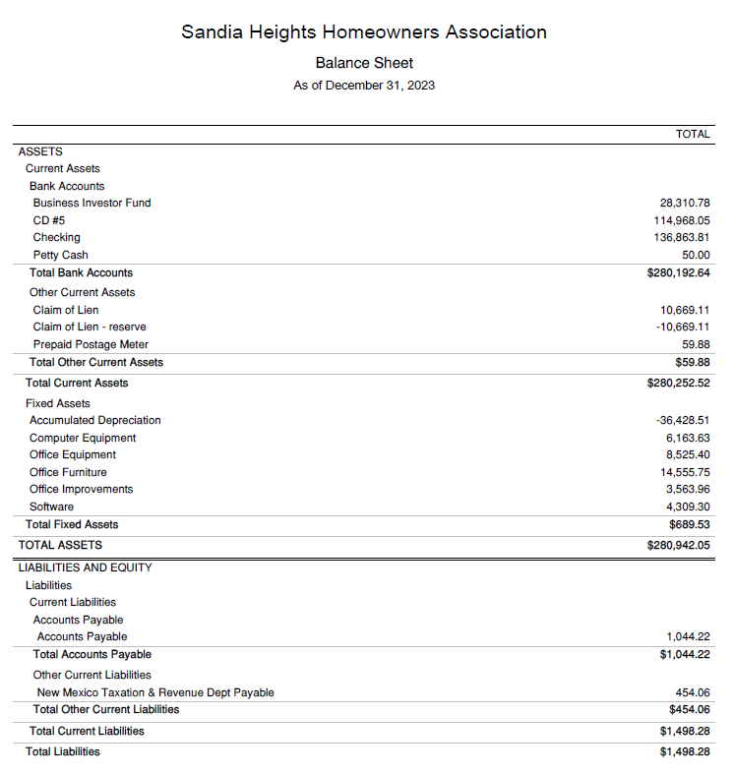

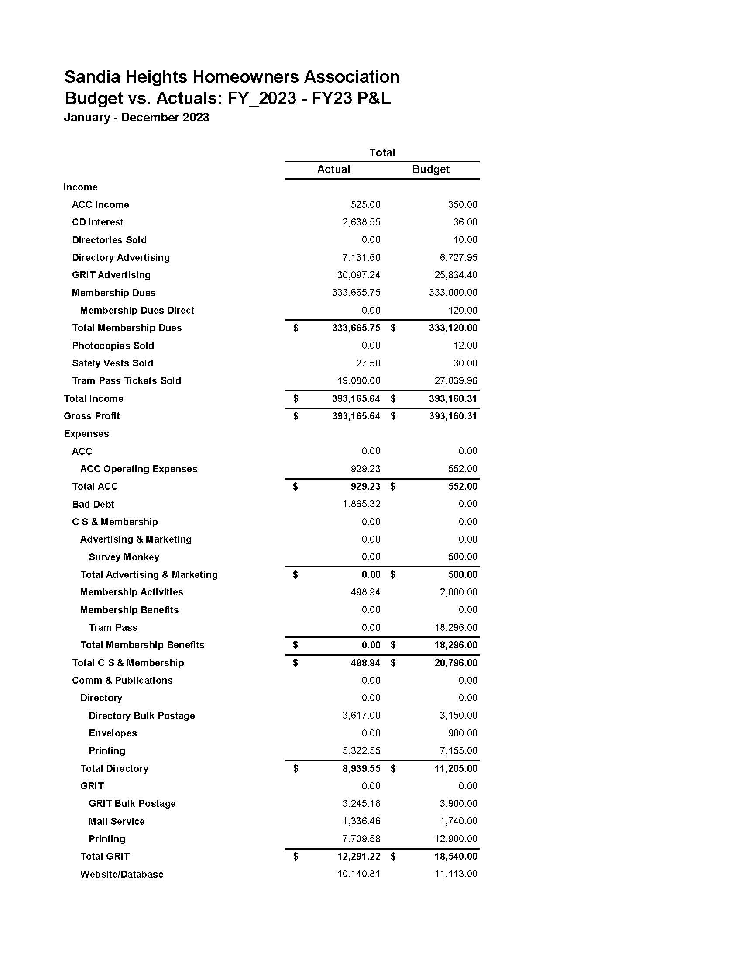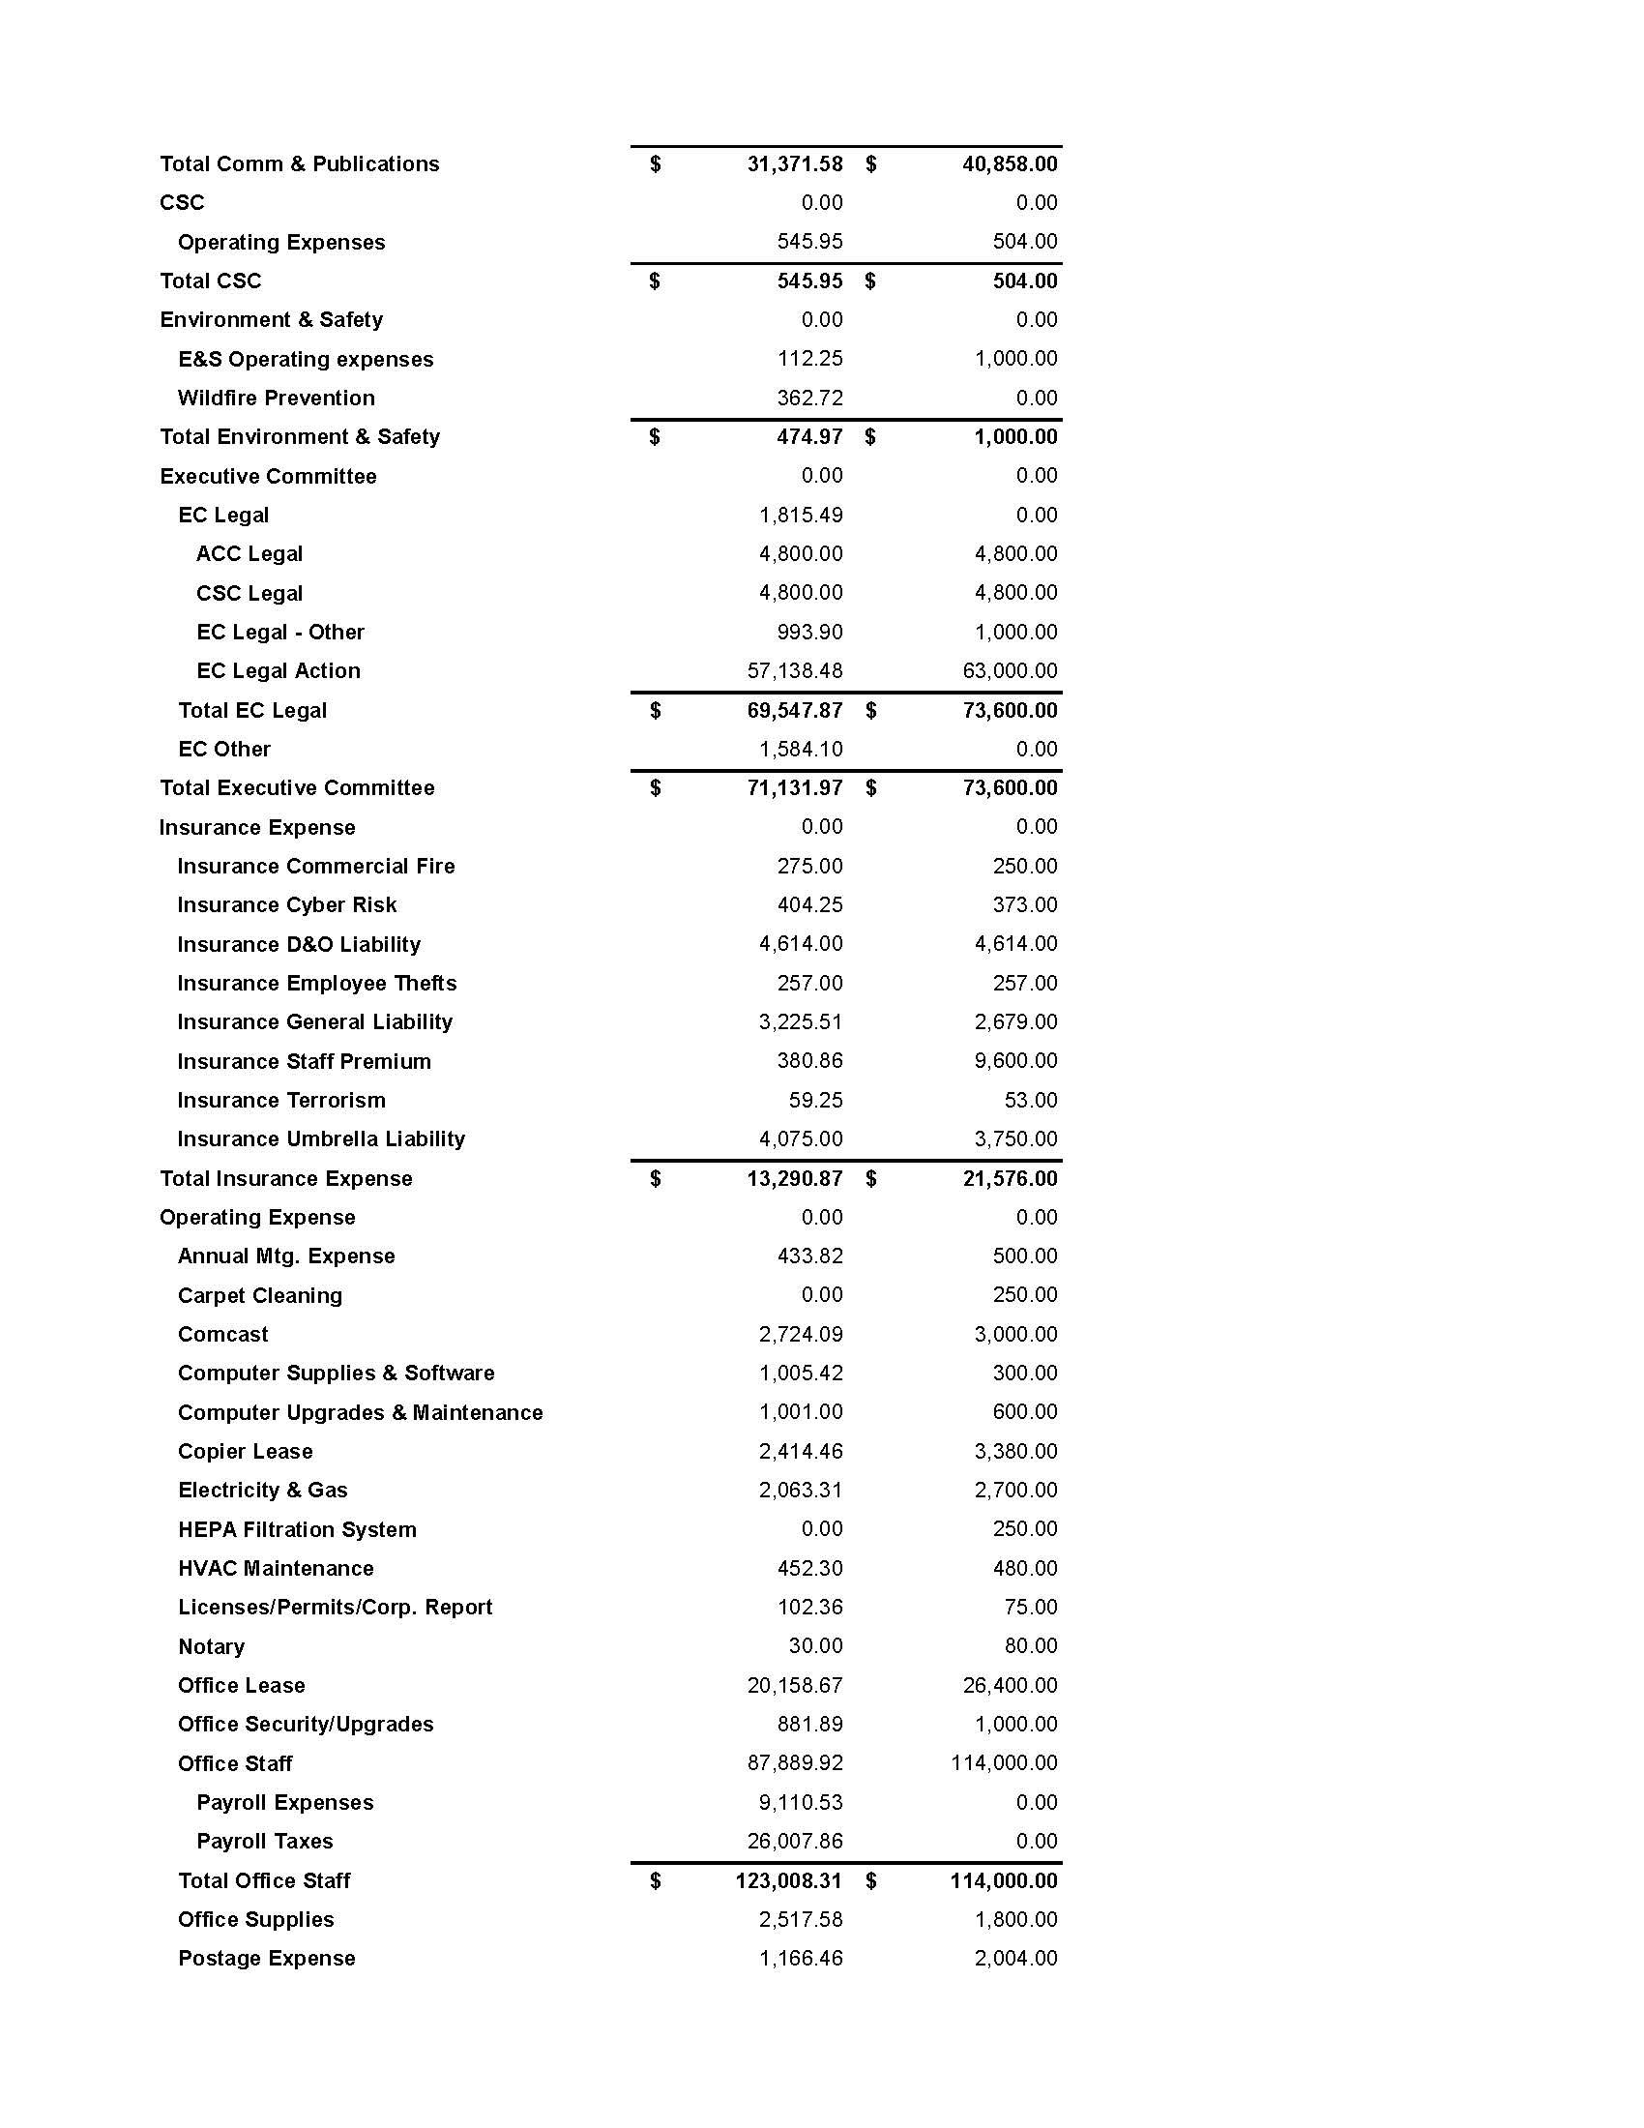

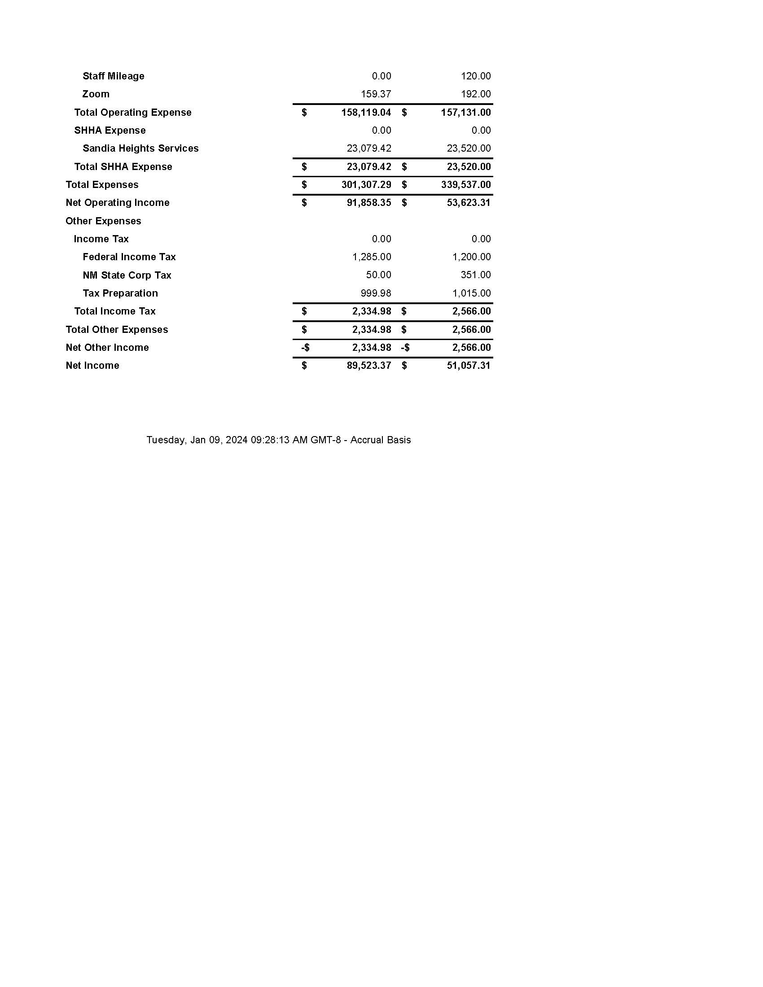2024 Annual Meeting Reports of Standing Committees

Architectural Control Committee (ACC)
Members:
Phil Krehbiel, Chair

Functions:
- Chartered by covenants for all SHHA Units
- Manages the architectural control process for SHHA by approving changes to the external appearance of properties.
- Conducts neighborhood reviews, if needed
- Strives to make decisions within 30 days of receipt of completed applications.
- Processes and manages about 300 projects annually.
- Generally, meets twice monthly.
- Publishes guidelines to assist residents with the design process.
- Maintains a log of active projects on the SHHA website and in the GRIT newsletter.
- Periodically publishes articles in the GRIT newsletter.

Summary of Activities for 2023:
A total of 303 applications were reviewed in 2023; 297 were approved.
The Committee filed a lawsuit against a lot owner seeking to remove an unauthorized structure. The owner resolved the covenant violation immediately upon being served with the court papers, and judgment was entered permanently enjoining the owner from the same violation.
A suit filed by the Committee in 2022 was settled after court-ordered mediation in early January 2024. The lot owner agreed to resolve an unapproved structure by acquiring enough land from an adjoining neighbor to eliminate a setback violation.
Suit was filed against SHHA and the ACC at the end of the year following disapproval of proposed new construction.
The Committee has begun a review and rewrite of guidelines regarding landscaping gravel, and approved colors for concrete driveways and walkways.
The Committee is in the process of updating color guidelines for stucco and exterior paint and trim.

2024 Annual Meeting Reports of Standing Committees

Communications and Publications (C&P)
Members:
Susan McCasland, Chair

Summary of Activities for 2023:
- Edited and laid out the monthly GRIT newsletter, adding content in each 2023 issue.
  - Jan: SH Tips & Hacks, Monthly Fun Fact, Albuquerque Open Space Foothills Trail Map, Fog, Trail News at Elena Gallegos (historical article)
  - Feb: SH Tips & Hacks, Predators, Monthly Fun Fact, View from Jack Rabbit Hill (historical article)
  - Mar: Annual Meeting officer and committee reports
  - Apr: Already a Brush Fire Near the Foothills?, Birds, Monthly Fun Fact, Mailbox Theft—What Can We Do?, Welcome to Spring
  - May: Woof! Woof! Is That YOUR Dog Barking?, Please Do Not Feed Wildlife, SH Tips & Hacks, Do YOU Love Sandia Heights?, Sunsets, One Man’s Weed (historical article)
  - Jun: Memories of an Old-Timer, The Artist Next Door, Wildflowers, Photo Contest
  - Jul: A New Look to the SHHA Website, The Artist Next Door, It’s Hot Out—For You and Your Dog, More Wildflowers, Photo Contest
  - Aug: Wanted: GRIT editor, The Artist Next Door, Dog Law, Photo Contest
  - Sep: Living With Bears, The Artist Next Door, Tips for Living With Bears, Photo Contest
  - Oct: Some Changes in Volunteer & Paid Staff, Dogs on the Loose!, The Artist Next Door, Autumn on Sandia Crest, More Photos Submitted to the 2023 Directory Photo Contest, Fun Fact, Please Obey Stop Signs, Photo Contest, Don’t Miss the Annular Solar Eclipse
  - Nov: We Need Your Voice, The Artist Next Door, Photo Contest
  - Dec: On the Subject of HOAs, The Artist Next Door
- Upgraded the resident database interface and the SHHA website.
- Oversaw and assisted office with publication of the 2024 Residents Guide and Directory.
- Instigated and oversaw changes to the SHHA website.
- Designed SHS utility bill inserts as needed for SHHA business.
- Responded promptly to member requests, comments, and complaints

2024 Annual Meeting Reports of Standing Committees

Community Service and Membership (CS&M)

Members:
Elizabeth Edgren, Chair

Functions:
Works to strengthen member benefits and to support and encourage social events that will build a sense of community in the SHHA.

Summary of Activities for 2023:
- Took the lead in organizing and hosting 2023 Annual Meeting.
- Conducted in-person welcoming of new neighbors several months of the year.
- Co-hosted Neighborhood Afternoon Out Ice Cream Social in September.
- Submitted articles in The GRIT:
  - What Do My HOA Fees Support? (Jan)
  - Little Libraries (July)
  - Neighborhood Afternoon Out (Aug, Sept, and Nov)
  - What is a Tutor Doctor? (Oct)
  - Balloon Fiesta Schedule (Oct)

Challenges:
- Committee inactive much of the year due to personal issues, few volunteers
- Coordinating well with changing office procedures

Statistics for 2023:
- On Jan 1, 2023 there were 1856 member households.
- On Dec 31, 2023 there were 1885 member households.
- 87% of 2172 households in Sandia Heights are members.*
- Tram Passes: Out of 2464 available, 1888 were used and 576 were not used. This represents a 76% usage rate.

64 lots remain vacant in Sandia Heights.

*The SHHA database currently shows 2172 as the correct total number of households, corrected from our past two years’ reports.

2024 Annual Meeting Reports of Standing Committees

Covenant Support Committee (CSC)

Members:
Art Romero, Chair

Functions:
Sandia Heights has Use Restrictions (Covenants) governed by over 39 sets of Covenants, each applying to a designated Unit within the community. The CSC works with property owners to enforce these legally binding documents. CSC provides covenant enforcement through a formalized process.

Formal complaints are submitted to the SHHA office by a Covenant Complaint Form found on the SHHA website or at the SHHA office. The identities of the complainant, the alleged violator, the address, and the nature of the complaint are considered confidential and available only to CSC members.

Many of the covenants were written in the 1960–1970 timeframes and do not specifically address some of the key issues we face today. For some complaints, the unit covenants do not cover or address the alleged violation and there is nothing the CSC can do to help. We are bound by what your covenants permit. Only the homeowners in a specific unit can change their covenants. The SHHA webpage offers guidance on how to change your unit covenants.

In some situations, the Bernalillo County zoning Codes and Ordinances are more restrictive than the SHHA covenants, such as for outdoor lighting, barking dogs, and yard trash. In these instances, we encourage the homeowner to file a complaint with the County. The SHHA office staff can offer guidance on contacting the County.

The CSC meets the first Tuesday of every month at 6:00 PM in the office conference room. If you plan to attend a meeting, we request that you notify the office 24 hrs. in advance and give your subject matter. Homeowners with questions or a statement to make to the Committee are allotted five minutes at the beginning of each meeting. Then the meeting goes into Executive Session to maintain the confidentiality of CSC business. The CSC Agenda and Minutes are for internal distribution only.

Summary of Activities for 2023:
The CSC handled 75 complaints in 2023, including 14 carried over from 2022. This compares to 31 over the previous year. All were investigated by CSC members and recommendations were made as to the validity of the complaints and actions to take for resolution if necessary. Of these, 63 were closed in 2023. Several complaints in 2023 required legal actions by the SHHA attorney.

2023 Successes and Challenges:
The CSC authored many articles in the GRIT in 2023. These ranged from reminders about trash bins and outdoor lighting to details regarding Airbnb-like rentals, septic systems, and radon testing.

Complaints dealing with trash bins and outdoor lighting continue to be a large part of the CSC workload. Significantly, in 2023 the CSC confronted several covenant violations dealing with parked RV’s, Airbnb-like rentals, and invasive elm trees. Many RV violations were successfully resolved and the RV’s removed, although with some difficulty in a few cases, and several are on-going. Unfortunately, two Airbnb-like violations could not be successfully resolved by the CSC and are now with the SHHA attorney for filing legal action in District Court.

It appears that Airbnb-like and similar short-term rentals will be a growing problem in Sandia Heights. All covenants prohibit the renting of part of a house, such as a room, but do not prohibit the renting of the entire house. It is worthwhile noting that two units in Sandia Heights have recently amended their covenants to prohibit short-term rentals of any kind, one for a minimum of 30 days and another for a minimum of six months.

Invasive elm trees are an increasing threat to the community. These trees have matured to heights that are beginning to diminish homeowner views, which of course impacts property values. Additionally, these trees are producing new saplings at an alarming rate. The CSC has very limited authority to enforce removal of these invasive trees, and so it is asking for homeowner cooperation to remove the trees. For instances where covenant violations have been filed, the CSC has sent “Good Neighbor” letters asking for neighbors to work together to remove both the offending trees and new saplings.

The CSC will aggressively enforce covenant violations of RV parking, Airbnb-like rentals, and is asking for homeowner help to combat the invasive elm trees. It is important and necessary for both SHHA committees and the homeowners, together, to endorse the SHHA dual Mission Statements – preservation of property values, and maintenance of the environment and unique quality of living in the Sandia Heights community. The CSC fully supports these Mission Statements.

2024 Annual Meeting Reports of Standing Committees Environment & Safety Committee (E&S)

Members:
Kathleen McCaughey, Chair

Summary of Activities for 2023:
  - Fire protection
    - Wildfire Risk Reduction Workshop, March 25 focused on hardening your home against wildfires and mitigating fire risk
    - Ongoing relationship building with Fire Station #35 - hosted lunch
    - Interactions with High Desert Fire Preparedness Committee
  - Elena Gallegos Open Space feasibility study
    - Continued GRIT articles keeping homeowners informed of status including “end of story” - permanent injunction filed
  - First Neighborhood Afternoon Out, planned and executed with Community Service & Membership Committee with focus on:
    - Socializing - ice cream sundaes and kid games
    - Strengthening partnerships with Fire Dept, Deputy Sheriff, and SHS Security making our neighborhoods safer
    - Focus on fire and traffic safety awareness, SHS Security services, encouraging neighborhood watches - know your neighbors and be aware
  - Cleanup of Tramway Blvd. between Paseo Del Norte and Simms Park Road - May & November
  - Also High Desert Development emergency egress impacts on Sandia Heights analysis
  - Multiple GRIT articles on Fire Prevention, EGOS Updates, Pulling Baby Weeds, Fireworks, New Roofing Materials, Get Rid of Your Dead Trees (and replace with climate-ready trees), New Member Solicitation

Ongoing Projects:
  - Community wildfire plan, Hardening Your Home Against Wildfires Seminars : biannual workshops
  - Adopt-A-Highway

2024 Annual Meeting Reports of Standing Committees

Nominating Committee (NC)
Members:
Hugh Prather, Chair

The Nominating Committee is chaired by the VP as prescribed in the SHHA bylaws. Members met multiple times over the course of the year to review Statements of Interest submitted by prospective Board members and to visit with each in a vetting process to assess interests and areas of service.

In the fall of 2023, a Zoom panel was conducted to interact with anyone who was interested in learning more about Board service and to answer questions. The session was very successful with intelligent questions and great explanations. Fortunately, this was recorded and is available for anyone who would like to become more familiar with the functions of the Board and committees. The link is https://sandiahomeowners.org/announcements/interested-shha-board-service-or-committe-member-service.

Six new Board members applied by submitting Statements of Interest and were approved by the Board as members (as provided by the bylaws) during the year. These six are:
- Heidi Komkov
- Eric Faulring
- Kevin Lloyd (who subsequently resigned in December)
- Phil Krehbiel
- Jim Stewart
- Suresh Neelagaru
- Terry Walker

David Crossley, Hugh Prather, Roger Hagengruber, Susan McCasland will be leaving the Board at the conclusion of this annual meeting.

Eric Faulring, incoming VP, will be happy to receive Statements of Interest from any of you who might be interested in Board service.

New Q&A Approach at 2024 Annual Meeting

As in the past, you will have an opportunity at this meeting to ask questions about the work of the Association or any aspect of the Association about which you are curious.

Due to the difficulty in previous years of immediately answering sometimes-complex questions that were submitted during the meeting itself, the Board decided to institute a new format for the Q&A section of the 2024 Annual Meeting.

We offered a mechanism for questions to be submitted in advance of the meeting by email or at the office, announced in The GRIT this month.

If you have a question today, please use the Annual Meeting Question Form that you find on the following page. You may submit written questions at today’s meeting, and we plan to have a written response back to you as soon after the Annual Meeting as possible.

